Literature Review - EYE (Deadline : **28/2**)

Key points to include

- Solid background on the project problem

- Situation and dynamics of the population and areas to be served

- Understanding and analysis of potential users

- Similar technologies/solutions currently used in other communities

- Strengths and weaknesses of existing solutions

- Any gaps in existing solutions, and

- Hence the opportunities to make your proposed solution distinctive to these existing solutions (specific aim in solution)

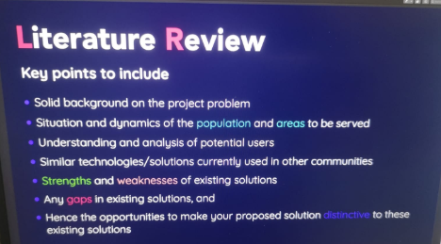

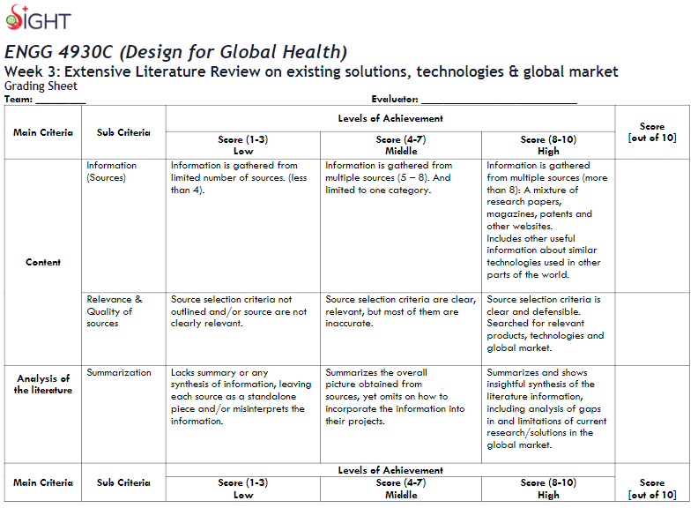

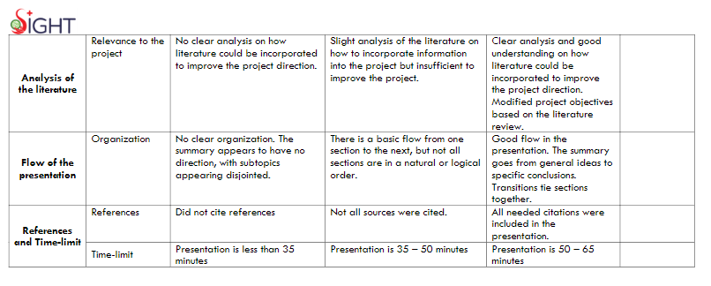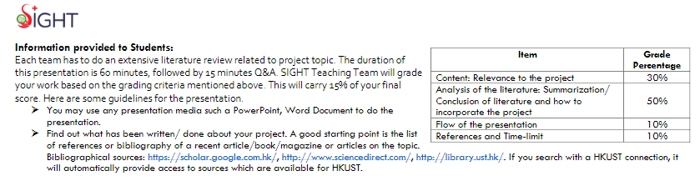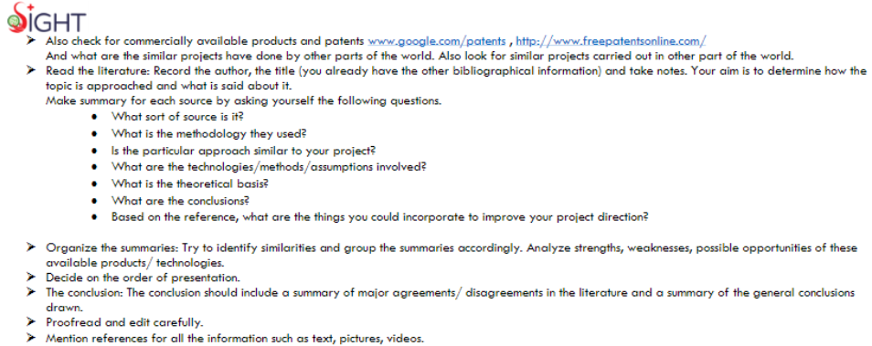55-65 mins presentation + 15 mins Q&A:

Background (define the problem in HK & Global): Jaman (10 min)

*Marketing research (HK & Global) : Tony & Ian **[not yet finished] ()**

Strengths and Weaknesses of existing solution (HK & Global) : Karen & Nora:D :) (20-25)

Any *gaps in existing Solutions (HK & Global): Tony & Ian **[not yet finished] ()**

Our Solution: Nora & Dogu (10 min) (connect)

Conclusion: Jaman (5 min)

Deadline ppt: 1/3/2020 (SUN) 5pm?

Rehearsal 1: 1/3/2020 (SUN)

Rehearsal 2: (Wed)

(13:30 -15:00pm-Next Fri - 6/3) Meeting with Meiyi

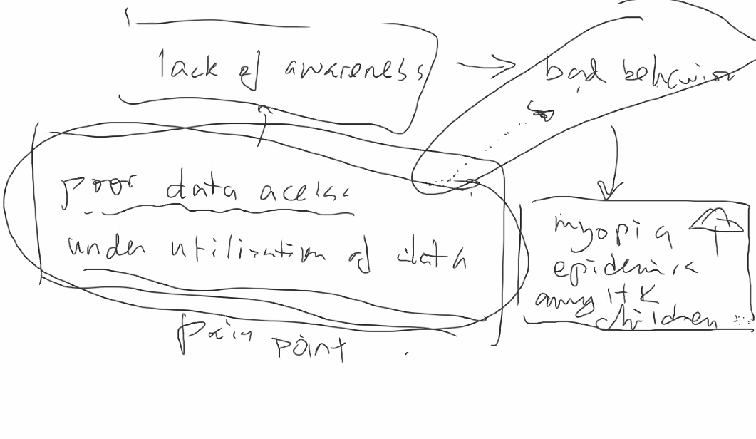

measurable things: X app usage (solution)

Problem: short-sightedness (**myopia**) problem among **kids** (HK) (an increasing trend - measurable? ) <big umbrella>

-behavior problem

-insufficient existing solution in HK govt (only in kids)

-data problem (low accessible)

-education

Causes: 1. HK eye health plan ?

(Dogu:) In HK people can’t access their eye health data easily, even if they do they can’t understand it (as it is very technical and lacks educational components) and act upon it.

-> Rephrased as

**Objective:** **Having a positive impact on HK children (age 3 - 16) myopia epidemic by letting the child patients, and their parents, access their data more easily and help them utilize the data via showing it more meaningful.**

Collect data more efficiently

Objective 1: Help Opticians to collect patients check-up data more efficiently

Objective 2: Improve accessibility and intuition of the data of the kids by themselves and parents

Objective 3: Educate (raise awareness?) Parents and Kids about the importance of eye health

(specific aim? timeline, solution, who make it, narrow down the tasks)

* 1. Completing the design (User Interface / User Experience) of the application which lets our clients record their data (15 Mar 2020)
* 1. Completing the data collection (backbone) part of the above mentioned application (30 Mar 2020)
* 1. Completing the backend programming and connecting it to the application (10 Apr 2020)
* 2. Programming the data visualization parts (25 Apr 2020)
* 3. Programming the educational components (2 May 2020)

Sustainability? RDS? Work for future?

Objectives (measurable things) : 1. improve the **problem of short-sightedness** among HK kids (data access)

1. how to measure???

2. educate parents and kids and **raise their awareness** of eye health (better)

& track their **behavior changes** (what kind of changes) of eyes

specific aim*proposed solution(how to achieve them) & timeline (when and how to complete)

Target: Kids with near-sightedness (HK) mainly? ; both of them(**parents with kids - general public / clients in private clinics / kids in eye hospital in HK?** )

application (parents) + watch(kids) ?

Kids = aged 3-16 (by Mr.Lo)

→ **information progressing differently**

**understand the ability of kids on using technical things (Don’t underestimate them)**

**-research kids (how old do kids use app?)**

Place: Hong Kong (more other places in research)

Lavenage others countries methods (how are they cope with it) (are they successful)

Solution: Data collection (backbone) -application (Alex Lam, email), VR game/glasses (extension)- pop-up activities, Education, watch (for kids) advice: charlie(app support), hardware etc

(data - easy for patients and doctors; meaningful to them; prediction for future eye health)

可行性

Karen discussed with Nora:

Application: two identities (doctors & clients:family mode/single mode) in one app + app simulation (diseases if serious myopia) (education-can linkage to kids) <front-end:user-interface & back-end: coding> + app notification <eye examination, usage time, exercises remainder> [timetable]

Education in order to have better behavior changes: videos (護眼操- steps by steps) <skills: animations> + health tips

Marketing solutions around the world (digital market): application examples

Evaluate awareness: Survey [measure objective’s successful ]

Partner: Eye hospital (contact with Jason) first

**objective: measurable?**

**Time (next meeting for Lit review presentation): 13:30 - 15:00 pm (Fri) with Meiyi (social science) - seems incorrect**

**1 hour (ppt) &15 mins Q&A**

**Bonus: video**

**Background (Jaman)**

1. **Definition of myopia**
2. **Myopia situation in hk**
3. **Why this target group (kids)**

**Comments: problem now, objectives, target group, place (HK) & global (research) (a quick outline)**

1. **Definition of myopia:**

**It is an eye disorder where light focuses in front of, instead of on, the retina. This causes distant objects to be blurry while close objects appear normal. Other symptoms may include headaches and eye strain.**

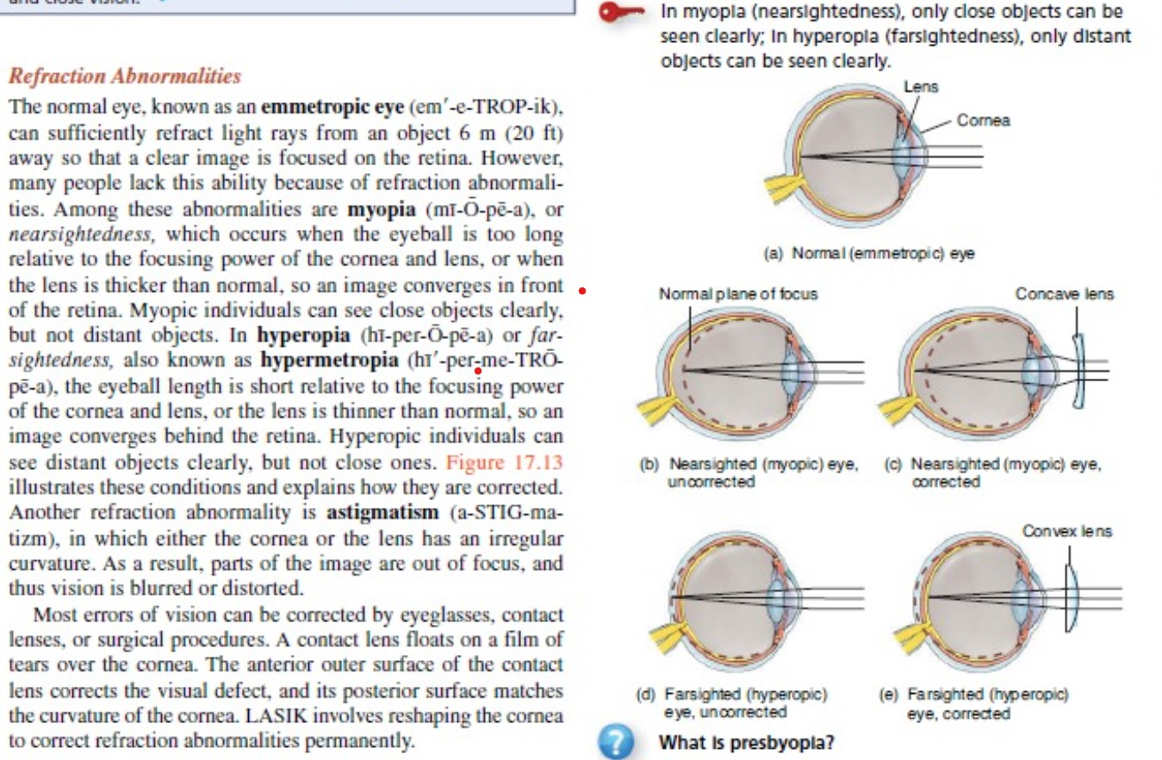

**Fig.1 Myopia from a medical book**

Gerald, J. T., & Bryan, D. (2014). *Principles of anatomy and physiology*. New York, United States: John Wiley & Sons Inc.

**What causes myopia?**

* **eyeball that is too long from front to back**
* **cornea that is too curved**
* **The exact reasons as to why myopia happens are not actually known, but there are two contributing factors that most experts agree on.**

1. **Myopia situation in hk:**

2.1) According to an article in the [SCMP](http://www.scmp.com/news/hong-kong/health-environment/article/2023072/doctors-raise-alarm-steep-rise-myopia-among-hong#comments), “Department of Health figures showed rates among primary and secondary pupils were 21.7 percent and 15.8 percent respectively in the 2014-15 school year.”

2.2) The rise in prevalence of Myopia have been discussed in different researches. The escalation trend on global prevalence of Myopia (Holden et al., 2017) (Fan et al., 2004) has been revealed, estimating a huge growth in the coming decades. Fan’s studies further denoted the rise in prevalence incidence and the progression of myopia of school children in HK, and the positive correlation between the incidence of myopia and the increase in age, proposing a spectacular risk for those who aged 10 and over 11 as there are approximately 1 in 5 children would suffer Myopia annually. The findings have been further supported by different researches (Lam et al., 2012; Holden et al., 2017), suggesting that the incidence level grows across ages.

Crown. (2018, July 30). Short-sightedness. Retrieved February 27, 2020, from <https://www.nhs.uk/conditions/short-sightedness/>.

Fan, D. S. P., Lam, D. S. C., Lam, R. F., Lau, J. T. F., Chong, K. S., Cheung, E. Y. Y., Lai, R. Y. K., & Chew, S. J. (2004). Prevalence, incidence, and progression of myopia of school children in Hong Kong. *Investigative ophthalmology & visual science*, *45*(4), 1071-1075.

Holden, B. A., Fricke, T. R., Wilson, D. A., Jong, M., Naidoo, K. S., Sankaridurg, P., & Resnikoff, S. (2016). Global prevalence of myopia and high myopia and temporal trends from 2000 through 2050. *Ophthalmology*, *123*(5), 1036-1042. Retrieved February 27, 2020, from <https://www.sciencedirect.com/science/article/pii/S0161642016000257>

Lam, C. S. Y., Lam, C. H., Cheng, S. C. K., & Chan, L. Y. L. (2012). Prevalence of myopia among Hong Kong Chinese schoolchildren: changes over two decades. *Ophthalmic and Physiological Optics*, *32*(1), 17-24.

McDonagh, M. (February, 2018). Lifestyle linked to huge increase in short-sightedness. Retrieved February 27, 2020, from <https://www.irishtimes.com/life-and-style/health-family/lifestyle-linked-to-huge-increase-in-short-sightedness-1.3397726>

1. Why this group (kids):

A one year longitudinal cohort study on prevalence, incidence and progression of myopia of school children in Hong Kong (Fan et al, 2004):

Hong Kong → owning one of the highest prevalence of myopia in the world

Myopia increased gradually from 18.3% at age 6 to 61.5% at age 12. (Lam et al., 2012)

Hong Kong children (6 years old) has the most shortsight rate (11.4%) in the world

Meanwhile, the shortsighted rate significant pointing upward in recent 3 years

44.5% children was suffering myopia

**Marketing research (Tony & Ian)**

- Prevalence of myopia

- Habit of kids and trend

In children aged 6-8 years, 25.0% were myopic, and among them, 12.7% for the 6‐year‐olds, 24.4% for the 7‐year‐olds and 36.1% for the 8‐year‐old. It was observed that prevalence decreased with ages and increased with education level. It reveals that when a kid grows up, the possibility of having myopia rises. HK has world’s highest rate of myopic kids, surpassed other countries and regions such as Beijing (7.4 percent), Singapore (6.6 percent) and India (5.9 percent).

# Table 5. Comparison of myopia prevalence, spherical equivalent refraction (SER), axial length (AL) and AL/corneal radius (CR) in China.

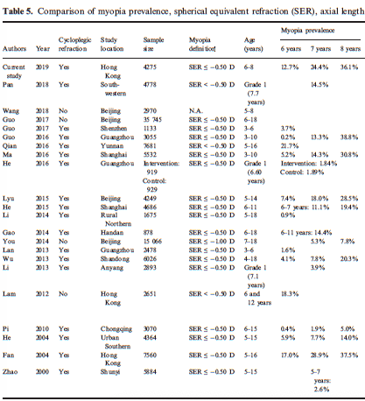

Reference:

# High prevalence of myopia in children and their parents in Hong Kong Chinese Population: the Hong Kong Children Eye Study

<https://onlinelibrary.wiley.com/doi/full/10.1111/aos.14350?af=R>

**Supplementary table 1. The difference of environmental factors between boys and girls.**

|  |  |  |  |
| --- | --- | --- | --- |
|  | **Boys** | **Girls** | **p-value** |
| **Outdoor time (hour/day)** | **1.49±0.65** | **1.41±0.6** | **<0.001** |
| **Outdoor sports (hour/day)** | **0.91±0.4** | **0.83±0.38** | **<0.001** |
| **Outdoor leisure (hour/day)** | **0.58±0.4** | **0.58±0.39** | **0.990** |
|  |  |  |  |
| **Near work** |  |  |  |
| **Watching TV (hour/day)** | **1.12±0.52** | **1.12±0.52** | **0.724** |
| **Doing Homework (hour/day)** | **1.35±0.39** | **1.35±0.4** | **0.782** |
| **Reading Books (hour/day)** | **0.77±0.38** | **0.79±0.37** | **0.127** |
| **Computer (hour/day)** | **0.61±0.44** | **0.58±0.45** | **0.040** |
| **Electronic devices (hour/day)** | **0.82±0.48** | **0.79±0.49** | **0.063** |
|  |  |  |  |
| **High Paternal Education level (%)** | **67.90%** | **66.29%** | **0.263** |
| **High Maternal Education level (%)** | **45.13%** | **44.05%** | **0.476** |
|  |  |  |  |
| **Height** | **125.4±7.86** | **124.21±8.03** | **<0.001** |

Taking the mean of activities, the time of usage of eyes for boys ranging from 6 years old and 8 years is (1.12+1.35+0.77+0.61+0.82=) 4.67 hours and for girls, it is (1.12+1.35+0.9+0.58+0.79=) 4.63 hours.

Reference:

# High prevalence of myopia in children and their parents in Hong Kong Chinese Population: the Hong Kong Children Eye Study

<https://onlinelibrary.wiley.com/doi/full/10.1111/aos.14350?af=R>

**Strengths and Weaknesses of Existing Solutions (Karen)**

Existing solution 1 (medical way)

PolyU optometry school - Defocus Incorporated Soft Contact (DISC) - cost HK$8,800 per year (4 sets of lenses as each pair has to be replaced every quarter) : correct child myopia

Strengths

1.DISC - 40 per cent cheaper than an existing myopia treatment in HK

2.DISC lenses - a clear image on the retina and a blurred image in front of it to prevent the eyeball from growing too large

3.DISC lenses - slow the progression of myopia by up to 60 per cent in primary school-aged children [e.g. clinical trials btw 2007 and 2009 on local children aged between 8 and 13 who wore the lenses for up to eight hours per day saw their rate of myopia progression slow by 60 per cent]

4. The wearers - avoid suffering from the adverse effect of drugs or surgery

Weaknesses

1. Wearing hard contact lenses at night - raise infection risk
2. HK education system - main reason that causes the short-sightedness becoming a public health issue among children who were required to study and write from a young age
3. DISC lenses - time consuming as users need to wash the lens every morning and night and need a special treatment (immerse the con into the solution (博視頓酵素除蛋白清潔液 BAUSCH+LOMB) for around 30 mins) every 2-3 days
4. DISC lenses - no permanent effect; the sight of users will change back to normal vision after 2 nights with no cons
5. DISC lenses - easily broken if those cons are accidentally dropped on the floor

Existing solution 2

Private Eye clinics such as Eye clinic, Quality Healthcare etc

Eye clinic - Children Myopia Care Plan : keep myopia under control to prevent eye disease in kids

Quality Healthcare - short-sightedness control and examination for children (aged 3-18)

Strengths

1. Provide doctor consultation
2. Oprometrist check-up (e.g. refraction, axial length measurement, instraocular pressure)
3. Diagnosis (Report, Explanation and Advice) by Ophthalmologist

Weaknesses

1. Each package in Eye clinic and in Quality Healthcare cost HK$3,200 and HK$1,550 respectively. All are expensive
2. Not a long-lasting plan
3. No long-term record

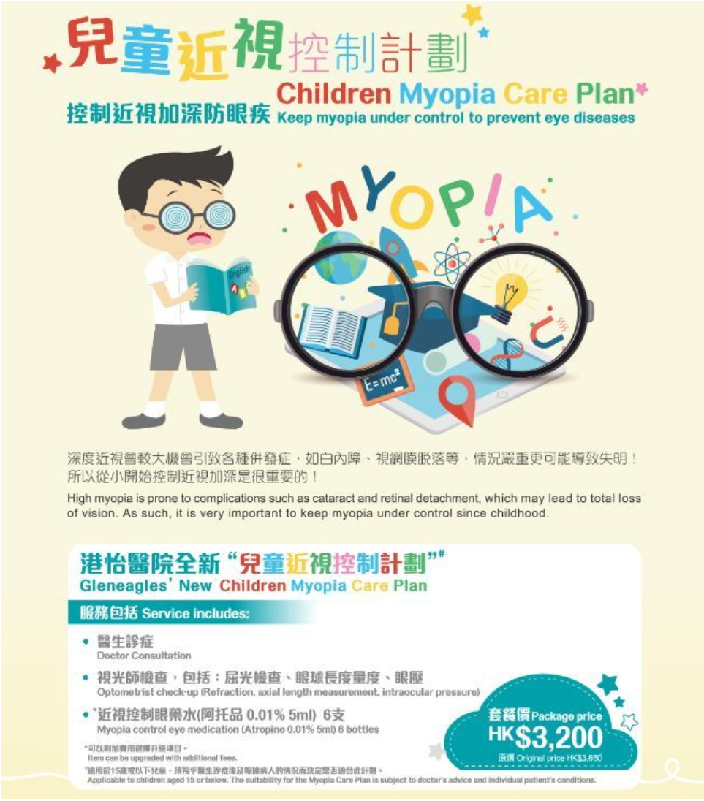(for existing solution 2)

Existing solution 3

HK govt - department of health - currently provides pre-school children aged 4 and over with a “pre-school child vision screening” service (「學前兒童視力普查」服務) by registered optometrists or orthodontists

* It includes vision inspection and binocular coordination.
* For children with weak or strabismus, it makes a preliminary refractive and fundus examination for them

VS

UK - UK;s National Health Service

* conduct eye examinations for children under 16 and nationals aged 60 or over

VS

Mainland - implement annual comprehensive eye examinations for school children : "Thirteenth Five-Year Plan" National Eye Health Plan (published in 2016)

VS

Canada - medical insurance plan of Ontario - provide free comprehensive annual optometry examinations for students under the age of 20 and citizens aged 65 or above or those with high risk factors such as diabetes and glaucoma

Strengths

1. Free of charge (aged 4 or over)

2. regularly

3. follow-up by primary school

Weaknesses

1. This current ophthalmological care for school children is not comprehensive
2. Too late to make the first examination at the age of 4

"The period from birth to 8 years is the golden age of vision development for young children. Visual development is generally completed at about 8 years old," said Lin Guozhen.

1. Not effective and quick to diagnoses and correct the vision problems
2. HK & China: focus on pre-school children only (it is still not universal eye examination): elder people cannot be helped in eye problem & Europe and canada: universal eye examination

Existing solution 4

HK govt - department of health - provide more eye health tips in the website in order to educate parents and kids

Strengths

1. useful Information and tips

Weaknesses

1. Lack of accessible channels (only website), difficult to raise the awareness of kids and their parents
2. Passive way of education

**Existing Solution(Eye care related application) on Google Play Store:**

**3 main types of app on solving the low awareness of myopia** *(included one app per each as an example)*

* Eye Exercises tracker or tutorial
* Eye care widgets(screen filter, eye user timer)
* Self Eye Exam
* Eye Sight Simulation

**1st type:**

|  |  |  |
| --- | --- | --- |
|  |  |  |

**Eye Exercises & Eye Training Plans (Chinese & English version) - Eye Care Plus:**

**Strength:**

* Detailed eye exercises and articles about eye diseases
* Easy to follow, step-by-step direction.

**Weakness: (why eye exercises type app cannot solve the problem)**

* Education materials are article-based, not patient enough to read through all text.
* Does not help with reduce refractive problems like myopia
* Not scientifically proven to improve eyesight.

### **Citation: KOMAL KRISHNA TIWARI, R. B.**

#### A Comparative Study on the Effects of Vintage Nonpharmacological Techniques in Reducing Myopia (Bates eye exercise therapy vs. Trataka Yoga Kriya)

<https://www.ncbi.nlm.nih.gov/pmc/articles/PMC57>

**2nd type:**

|  |  |  |
| --- | --- | --- |
|  |  |  |

**My Eyes Health Protection App: Screen filter and timer**

**Strength:**

* Behaviour change, use 20-20-20 rule, prevent/slow down myopia
* Rest for 20-30 seconds after every 20-30 minutes of screen use

[**https://www.studenthealth.gov.hk/english/health/health_ev/health_ev_nea.html**](https://www.studenthealth.gov.hk/english/health/health_ev/health_ev_nea.html)

**3rd Type: Self Eye test**

|  |  |  |
| --- | --- | --- |
|  |  |  |

**Eye exam:**

**Strength:**

* Self checking, make basic diagnose yourself, discover problem earlier

**Weakness:**

* Accuracy problems

**4th Type: Eye Sight Simulation**

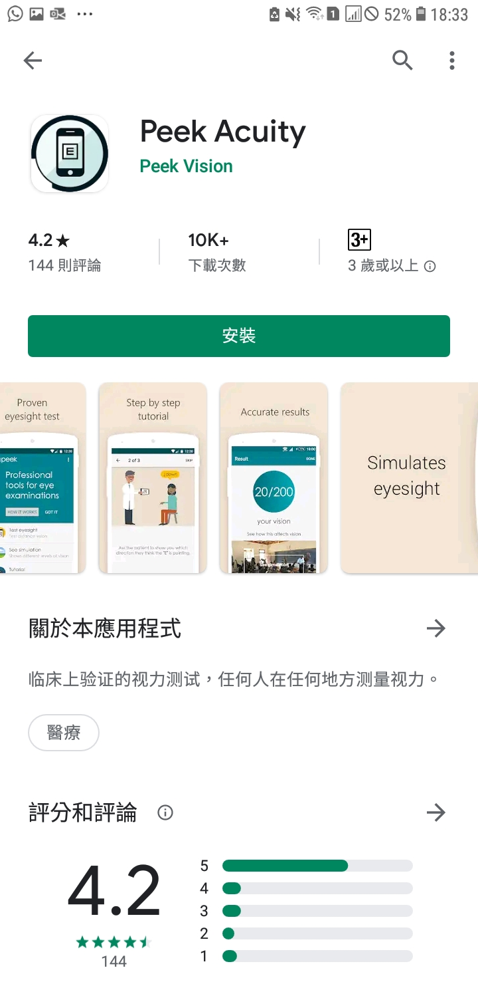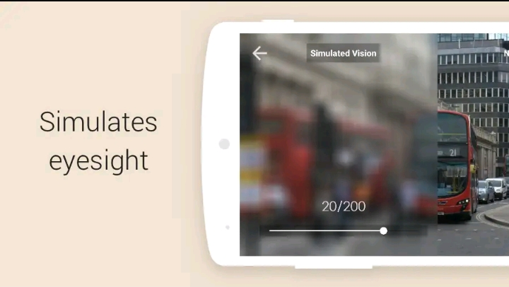

**Peek Acuity: vision check app to check visual acuity using only an Androd smartphone**

**& Help screen and identify people who need further examination & Data analysis**

**& SMS reminder**

**Strength:**

1. **Provide measure of visual acuity and a visual representation of the result for easy explanation to patients**
2. **Includes simulated representation that helps explain result to patients**
3. **Includes equivalents of “count finger”, “hand movement”and “light perception”**
4. **Scores are provided in standard units of Snellen - including metric (6/6) and imperial (20/20) and LogMar (0.0)**

**Weakness:**

**1. Using only one letter “E” underestimates the eye power (inaccuracy)**

**2. Shaking feature adds hassle to the process of eye examination**

**3. No any settings about the size of the screen**

**4. No scaling option**

[**https://play.google.com/store/apps/details?id=org.peekvision.public.android&hl=en&showAllReviews=true**](https://play.google.com/store/apps/details?id=org.peekvision.public.android&hl=en&showAllReviews=true) **(review of the app)**

**This one really similar!!!!! How do we distict from it???**

**Existing solution Website**

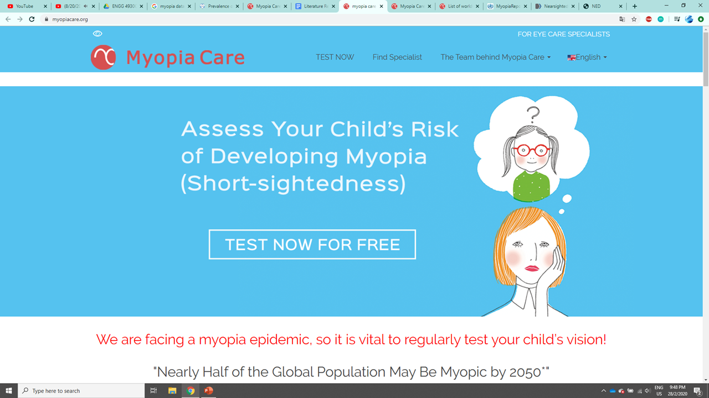

<https://www.myopiacare.org/>

“Using a simple questionnaire, it can estimate the level of risk and, if needed, provide you with contact details of a local expert who can help. This allows early intervention, increasing the probability of a successful outcome.”

**(Parents side)**

Target audience: parents who want to know if their children (3-18) have myopia or not.

1.Questionnaire for parents

Ask about child’s age, current eye situation, lifestyle(e.g.hour spent outdoor)

2. Show the risk of myopia and recommendations on lifestyle change

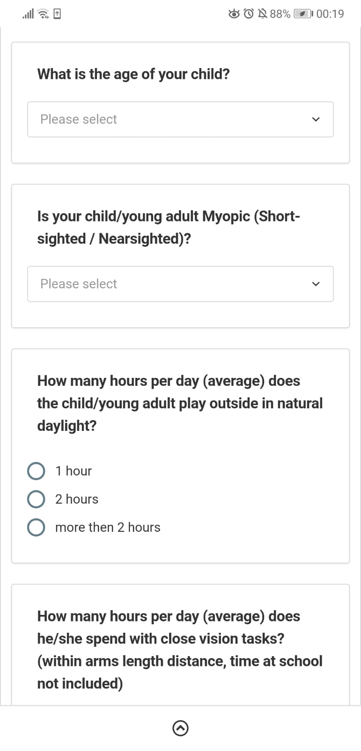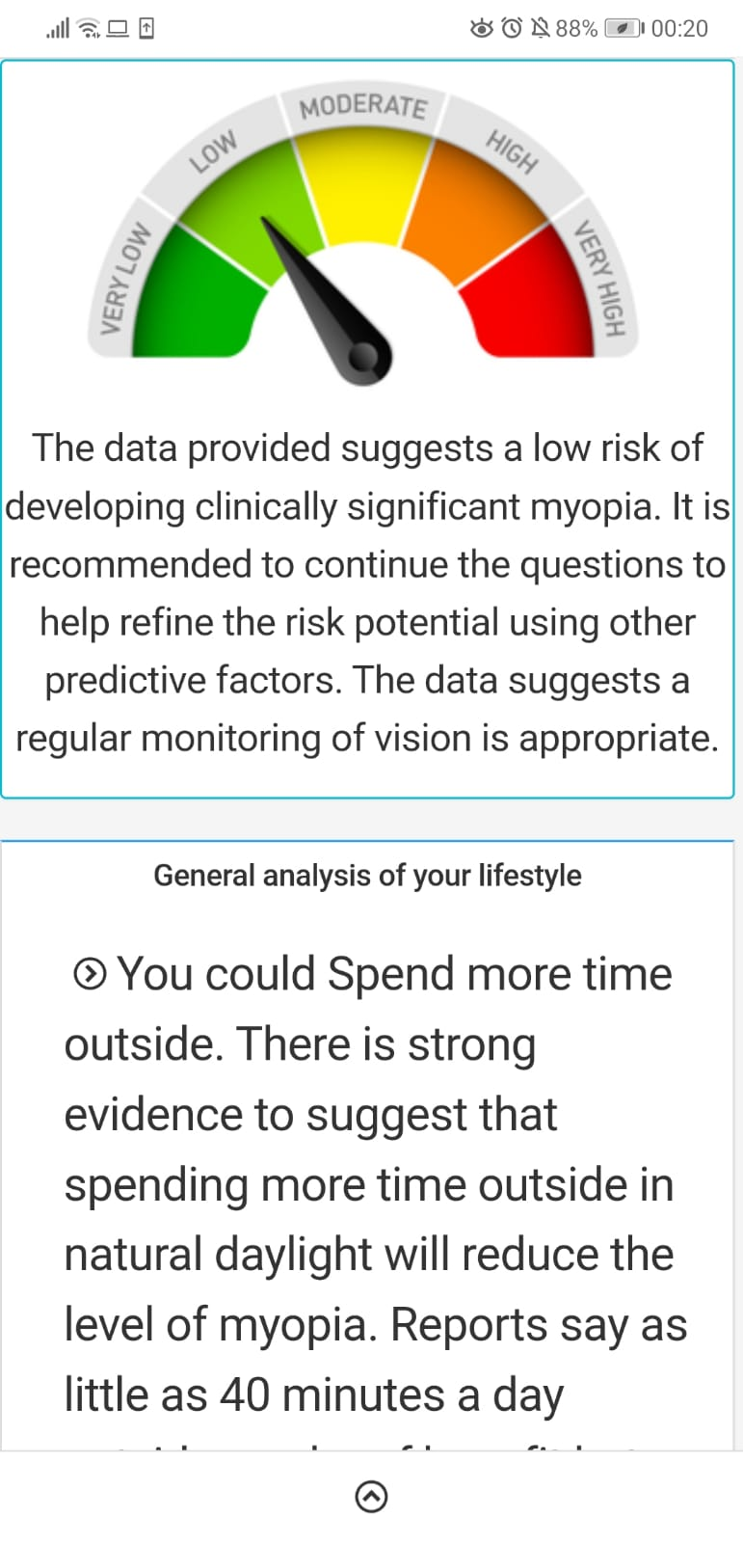

3.Show a **code** after the test (Present to professionals to get the questionnaire result)

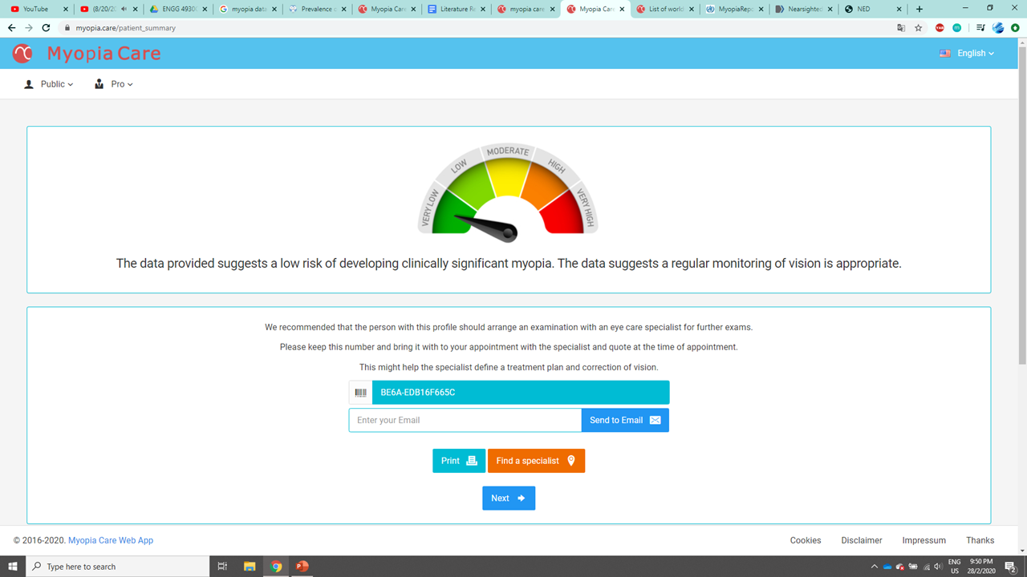

4. Find local specialists(3 professionals in HK)

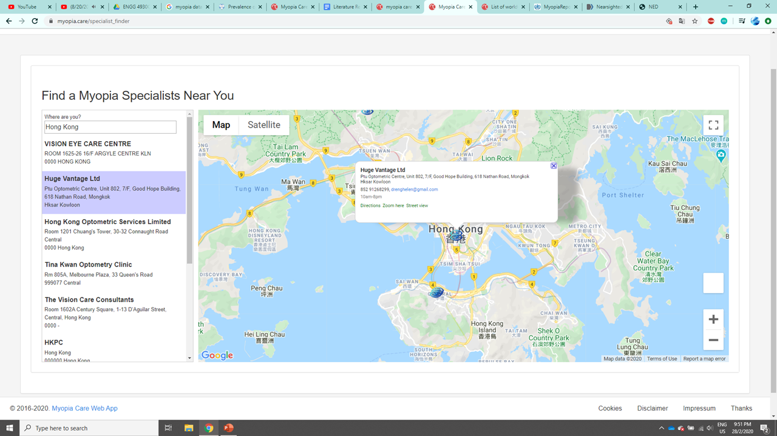

**Strength:**

* Provide personalize advise on lifestyle changes
* provide information of experts

**Weakness:**

* Limited number of professionals in Hong Kong is displayed in this website
* Cannot access their own data
* Passive way of education - display information only

**(Professionals side)**<https://www.youtube.com/watch?v=nCNnIPqD7uQ&feature=youtu.be>

Target audience: professionals who are actively engaged in myopia control. (with treatment, not just glasses)

1. Enter the code to create new record

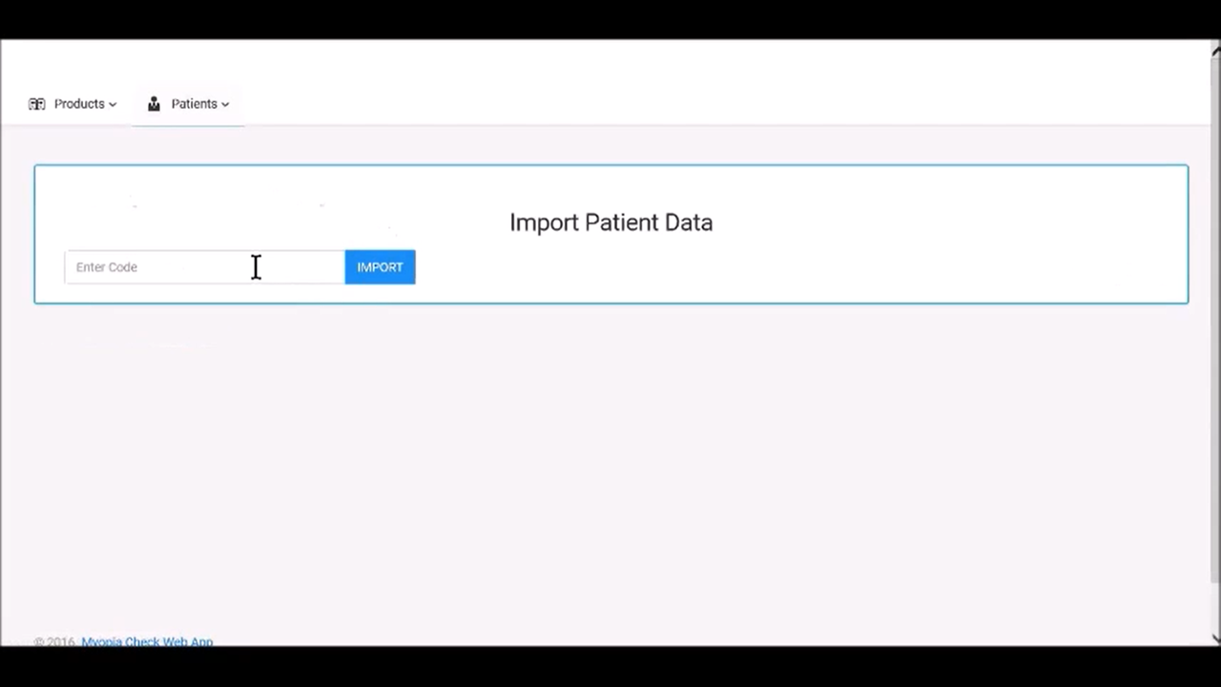

2.Data Input(Personal info,eye status,current treatment,persciption history)

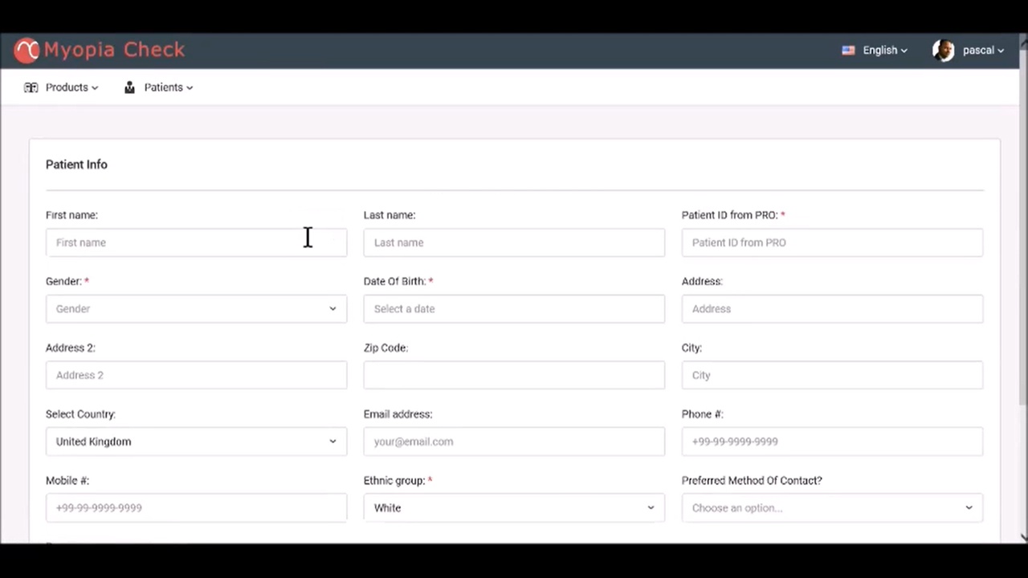

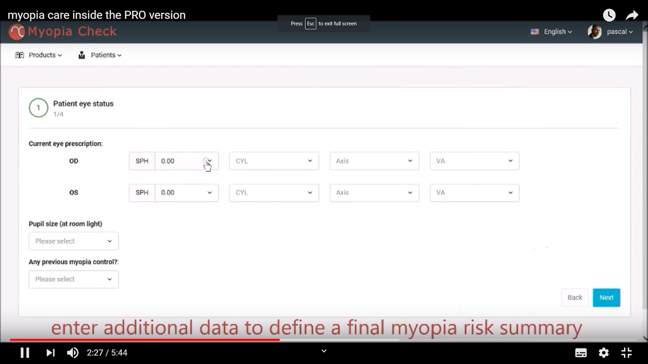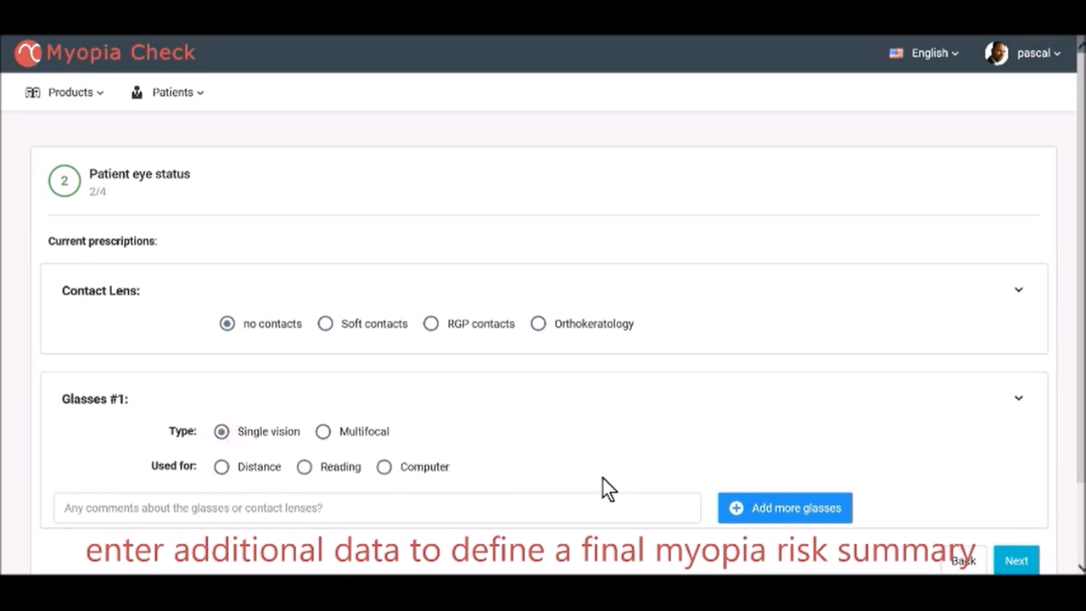

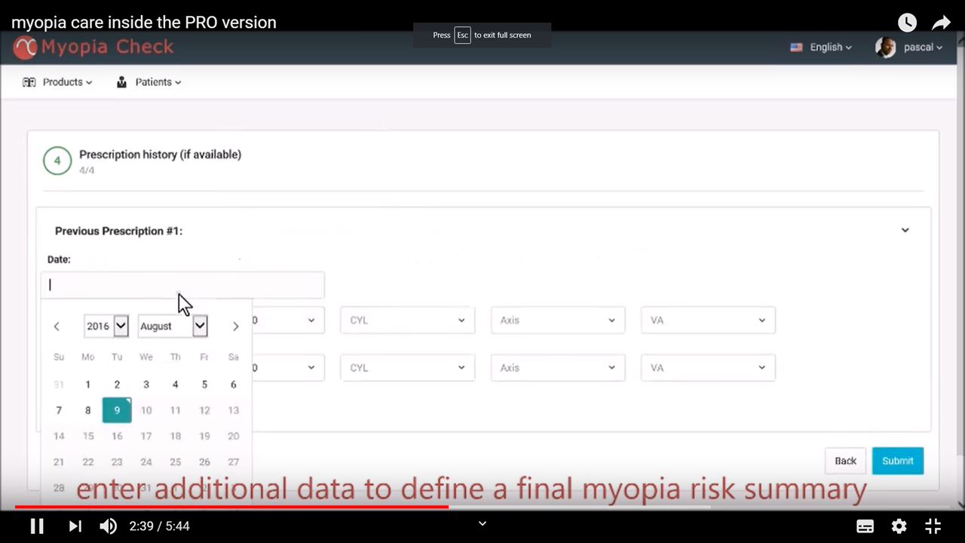

3.View all the patients’ data

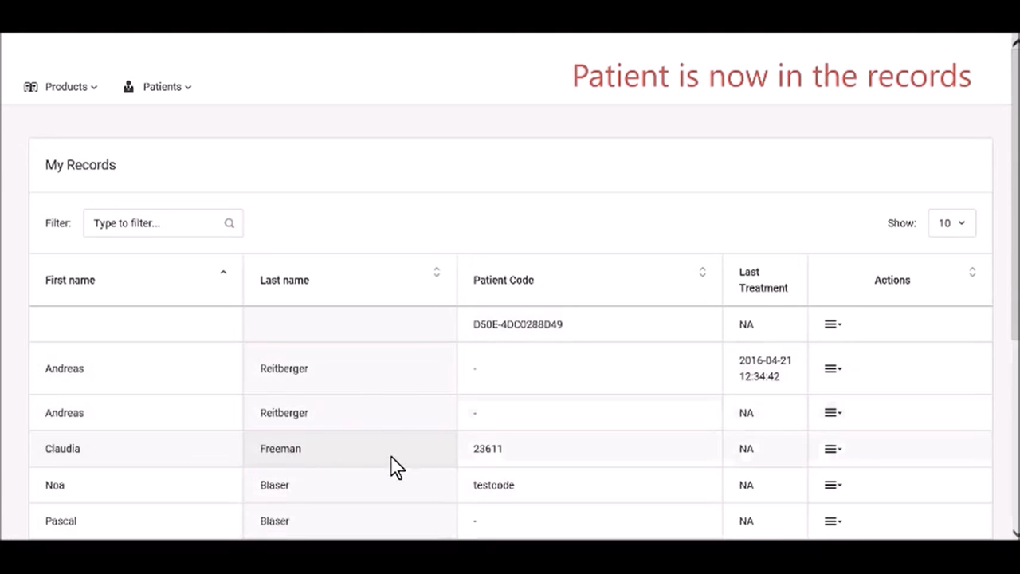

4. Report on the risk of having myopia

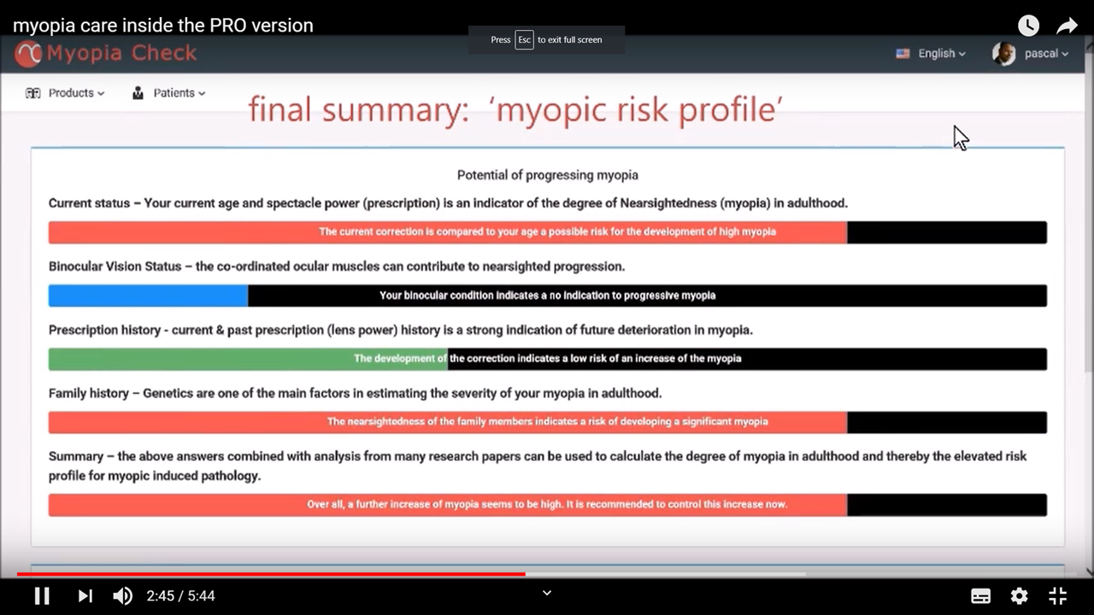

**Strength:**

* With the code, can access kids’ family myopia history/lifestyle/current eye health very easily
* pre-defined input field

**Weakness:**

* No visualization on data, not much different from viewing an excel form

**Any Gaps in Existing Solutions (Tony & Ian)**

Gaps in existing solution 1:

1. Some people whose eyes are easily getting allergic can not use this method.
2. The efficacy of the DISC is hard to test since the past data is not easily for the patient to access.

Gaps in existing solution 2:

1. It would cost more for every people to get a private doctor .
2. The quality of the service that private doctor is hard to evaluate.
3. If patients change their private doctor, their previous data might not able to give the new doctor.
4. The patient always has to reserve for a private doctor which means it’s hard for them to access the private doctor in emergency situation.

Gaps in existing solution 3:

1. Many people don’t go regular eyecheck after graduating.
2. The previous data of children is hard to keep.

Gaps in existing solution 4:

1. The eye information is only on the website which is not easy for people to get those knowledge or even raise their awareness of there eyes.
2. The presentation of the website is not catchy for people.

**Our Solution (Nora & Dogu) + what makes it distinct from other solutions**

= How do we fill the gaps??

No cost on the users, change patients behaviours from a young age, cultivate good habit, prevent eye disease in the long run

Data collection + Educational program

Data collection:

Details:

* Doctor enters check-up data
* save to database
* send whatsapp/sns to parents to receive reminders(Checkups appointments/Good habbits)

Objectives:

* keep record, discover abnormality at early stage
* Remind parents to go do eye check-up

Why is this solution needed: (Fill the gap)

* Currently no effectient data collection system for small clinic/organization
* Many doctors don’t have the technical background to set up a database

Why Unique:

* (VS traditional database input system): more mobile, can input data of the same patient in different rooms, doesn’t require login or search the patients to enter data every time, save time
* (VS Excel file): clean input form, easy to view patients’ data with the search function
* (VS paper record): save physical space, easier to keep record for a long time

Proposed educational program: VR simulation

Details:

* A simulated scene(from daily life) for the patients to experience in
* Simulate the vision with current prescription and future prescription (maybe different diseases???)Will simulate different diseases better than simulate various kind of
* interactive with the data collected ??
* One time experience?? How to make long lasting effect??
* Within 10 minute???

Objectives:

* Realise the inconvenience in daily life with myopia
* Realise that myopia is not something that can be ignore. Wear glasses cannot solve all problems. higher degree of myopia can lead to higher chance of eye disease
* Possibly educate how to keep their eyes healthy (eg.Rest your eyes every 20 minutes. Look 20 feet away for 20 seconds.)

Why is VR needed?/better? (Fill the gap)

* More engaging experience than traditional form(leaflets/comic/cartoon) of eye care education
* More attractive to children

*Research done on effect of using VR as educational tool (learning time: 7min)(19 yr-old):*

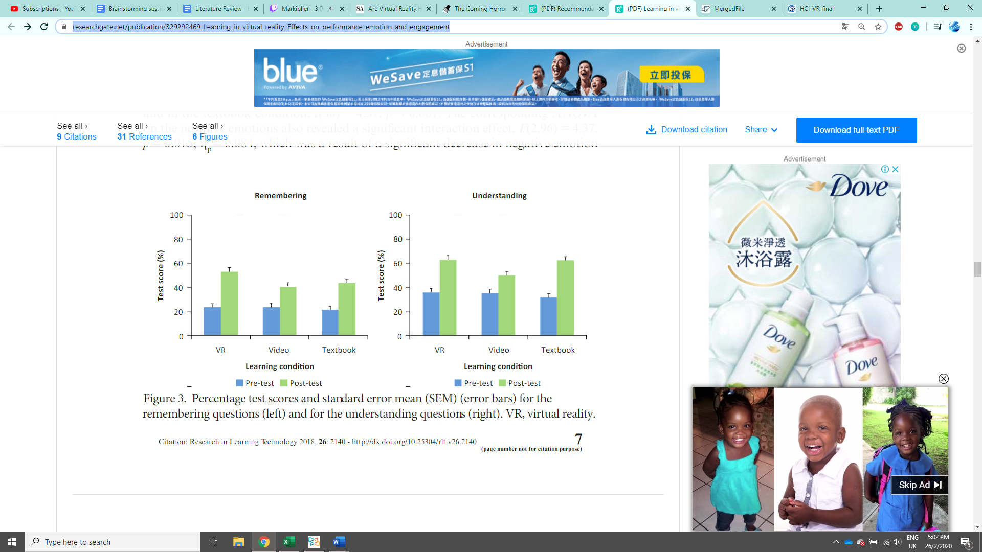

More effective than using textbook and video in remembering and understanding information

Allcoat, Devon & Von Muhlenen, Adrian. (2018). Learning in virtual reality: Effects on performance, emotion and engagement. <https://www.researchgate.net/publication/329292469_Learning_in_virtual_reality_Effects_on_performance_emotion_and_engagement>

*Are VR headset safe for children?*

<https://www.scientificamerican.com/article/are-virtual-reality-headsets-safe-for-children/>

"The brain is very plastic in young ages, and prolonged exposure with improperly fitted devices could incur damage,"

“American Academy of Ophthalmology says there is no evidence that long exposure to screens can cause permanent damage.”

The game will not be prolonged.

*Virtual Reality and Learning: Cognitive and Motivational Effects of Students’ Sense of Presence* <http://citeseerx.ist.psu.edu/viewdoc/download?doi=10.1.1.105.7125&rep=rep1&type=pdf>

did not affect learning performance in college kids, but experiments found out that they are more positive towards the learning experience and are more motivated to learn more.

Reference: <https://www.scmp.com/news/hong-kong/health-environment/article/2130044/contact-lenses-invented-hong-kong-correct-child> (existing solution 1)

<http://www.bausch.com.tw/zh-tw/our-products/contact-lens-care/gas-permeable-multi-purpose-solutions/boston-one-step-liquid-enzymatic-cleaner/> (博視頓酵素除蛋白清潔液 BAUSCH+LOMB)

<https://www.studenthealth.gov.hk/tc_chi/health/health_ev/health_ev_cl.html> (健康資訊 - 隱形眼鏡的選擇及護理)

<https://www.qhms.com/health-screening/other-health-check-qh-children-eye-examination.aspx?lang=en> (Quality Healthcare)

<https://gleneagles.hk/facilities-services/explore-facilities-and-services/specialist-outpatient-clinics/eye-clinic> (Eye clinic)

<https://www.peekvision.org/> (Peek Vision)

<https://www.info.gov.hk/gia/general/201605/11/P201605110681.htm> (pre-school vision screening)

<https://www.eyeclinic.hk/> (eye clinic)

<https://en.wikipedia.org/wiki/Hong_Kong_Eye_Hospital> (hong kong eye hospital)

<http://www.hkos.org.hk/?section=Top&id=43> (HKOS)

<http://www.hkos.org.hk/upload/Top/children_eye_care.pdf> (children eye protection brochure in HKOS)

<http://www.hkspo.org.hk/en/information.php> (HKSPO)

<http://www.hkspo.org.hk/upload/optometrist_pdf/Referral%20list_2020.pdf> (HKSPO)

<https://www.seedoctor.com.hk/org_detail.asp?org_id=12146> (香港視網膜病變協會 Retina Hong Kong)   
<https://www.seedoctor.com.hk/ophthalmology-specialty-information.asp> (all info of org)

<https://en.wikipedia.org/wiki/Eye_care_in_the_United_Kingdom> (UK)

<http://www.uniteforsight.org/eye-care-policy/module2> (canada)